Economics 358 Assignment 2 (version A)

This assignment has a maximum total of 100 marks and is worth 20 percent of your total grade for this course. You should complete it after completing your course work for Units
6 through 9. Answer each question clearly and concisely.

- Define the natural rate of unemployment in terms of wage-setting and price-setting relations. Write the equation that expresses the natural rate of unemployment in terms of these relations. Using an appropriate diagram, explain the effect of a decrease in unemployment benefits on the natural rate of unemployment.
(20 marks)
The natural rate of unemployment can be defined using wage setting and price
setting relation. The rate of unemployment is either increased based on the wage
setting, this is where the employees are influenced to either work or not depending
on the pay they get. The price setting is on the other hand also involved in this as
when the prices are higher the wage setting will be higher too. The real wage can
therefore, be denoted as the rate of wage setting by the price setting(w/p)
we observe that if the real wage reduces them the level of unemployment increases
as this lowers the morale of the employee, price setting is responsible for the
change in the market demand of the product, it therefore is responsible for
evaluating profits to be earned.
We can therefore express the natural rate of unemployment as ($w/p$) where w is the
wage setting and p is the price setting.
We can further derive the formula as follows
Wage setting(w)$=p^{e}$f(x,y)
$p^{e}$ being the expected price, x the rate of unemployment and y the variable.

Price setting (p)=(1+µ) w
where µ is the additional charge to the price so as to accommodate profit.
The $p^{e}$ can also be defined as the average price therefore
$p^{e}=p$
w = p f(x,y)
hence

($w/p$) = f(x,y)
And
($w/p$)=$\frac{1}{1+µ}$

We can now say that natural state of unemployment is
f(x,y)=$\frac{1}{1+µ}$

as shown above a reduction in the unemployment benefits causes a decrease in
natural level of unemployment.
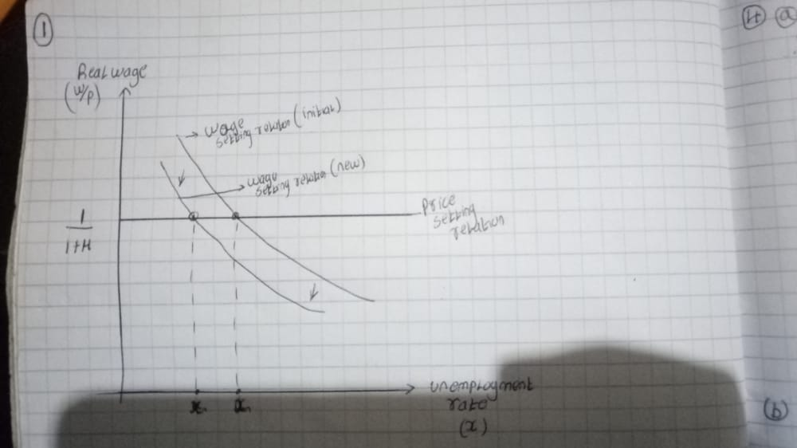

- a) What is the shape of the aggregate supply (AS) curve if:
  - Nominal wages and prices are flexible and competitively determined?
(5 marks)
taking Y on the horizontal axis and P on the vertical axis considering that
this applies where the output of the employment is maximum, the graph will
shift to the right as variable increases.
  - Nominal wages are downwardly rigid? (5 marks)
According to Keynes theory nominal wage are downwardly rigid when workers object deductions in their pay. therefore, a reduction in nominal
Wage then the supply at price level will increase hence causing an outward shift
b) What is the importance of the slope of the AS curve from the standpoint of
stabilization policy? (10 marks)
there exists a direct relationship between two variables, this means that
an increase in one variable leads to the increase in the other variable this
criteria is therefore important in stabilization policy

- Answer the following questions assuming known IS and LM curves.
- Derive the associated aggregate demand (AD) curve. (5 marks)

The location of the equilibrium (E) is where the IS and LM
Curves meet each other. Both the demand and supply are said
to be at equilibrium
the point E is also where demand level and supply level are both
P0 and Y0 if therefore there is a rise in price levels then there is
a drop in the supply the LM now meets the earlier LM at a new point
say E1 the supply level becoming Y1 consequently the other panel is
E1 and P1
The AD curve can hence be defined by joining points E1 and E
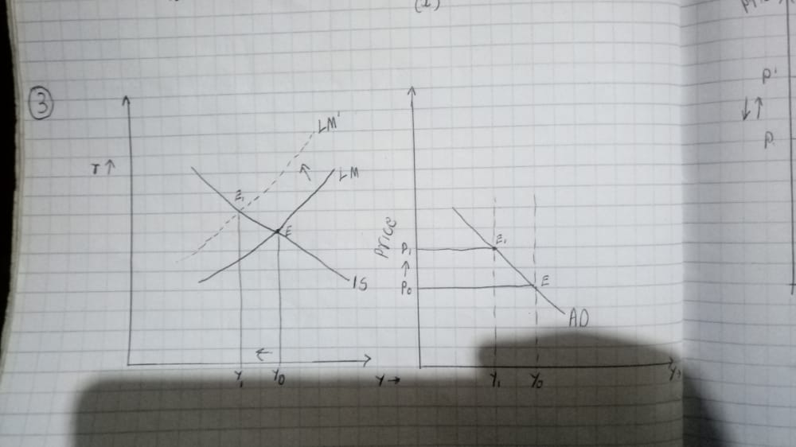

- Why does it have a negative slope? (5 marks)
There is a negative relationship between supply and price this causes the
AD curve to slope negative. When the prices are lower the output are higher
Thus the supply of money is held at a constant.
- What is the effect of an increase in taxes on the AD curve? (5 marks)
An increase in taxes means that the money supply in the public will reduce
this will further cause a drop in the demand causing overall AD curve to shift leftwards as it falls.
- What is the effect of a decrease in real money balances on the AD curve?
(5 marks)
A reduction in real money balance means that the price level also increases
There will be upward movement along the curve as the LM curve shifts to the left.

- Assume the economy starts at the natural level of output. Using AS-AD analysis, compare the adjustment in the economy to an increase in government spending under fixed exchange rates with
- downwardly rigid wages and prices. (10 marks)
an increase in the government expenditure moves the AD to the right A$D^{1}$
the price level will however not change but the increase in output of Ys.
This in turn means that there will be increase in demand reducing the money
Value. This causes the central bank to sell foreign currency to reduce the money supply in rotation. A shift to the left is observed hence A$D^{1}$ to AD.
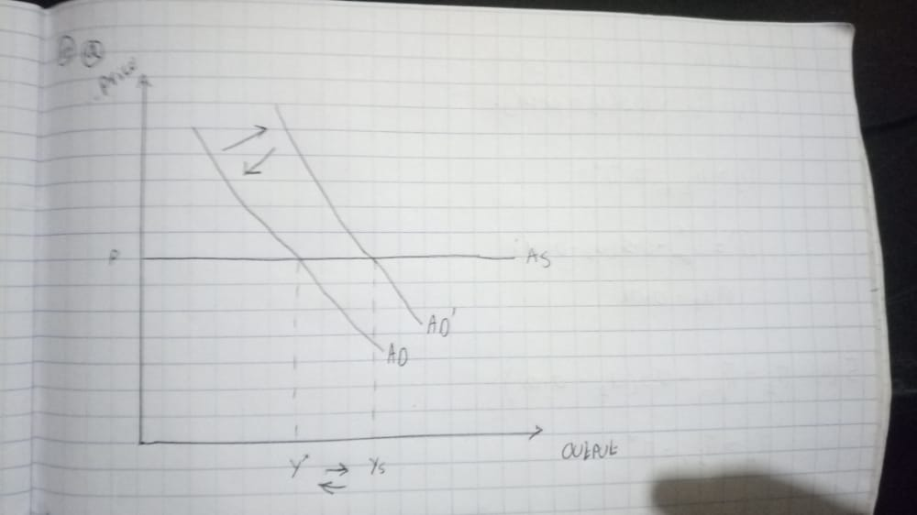
- competitively determined wages and prices. (10 marks)
Competitively determined wages and prices cause supply to be vertical. Increase in price levels lower currency value to be able to sustain the exchange rates as fixed then currency supply is reduced leading to initial price levels and output.

- Consider the Phillips curve π_{t} = π_{t-1} – 0.5(u_{t} – 0.01).

- What is the natural rate of unemployment? Graph the short-run and long-run relationships between inflation and unemployment. (5 marks)

- How much unemployment is necessary to reduce inflation by 3%? Compute the sacrifice ratio. Show your work. (5 marks)
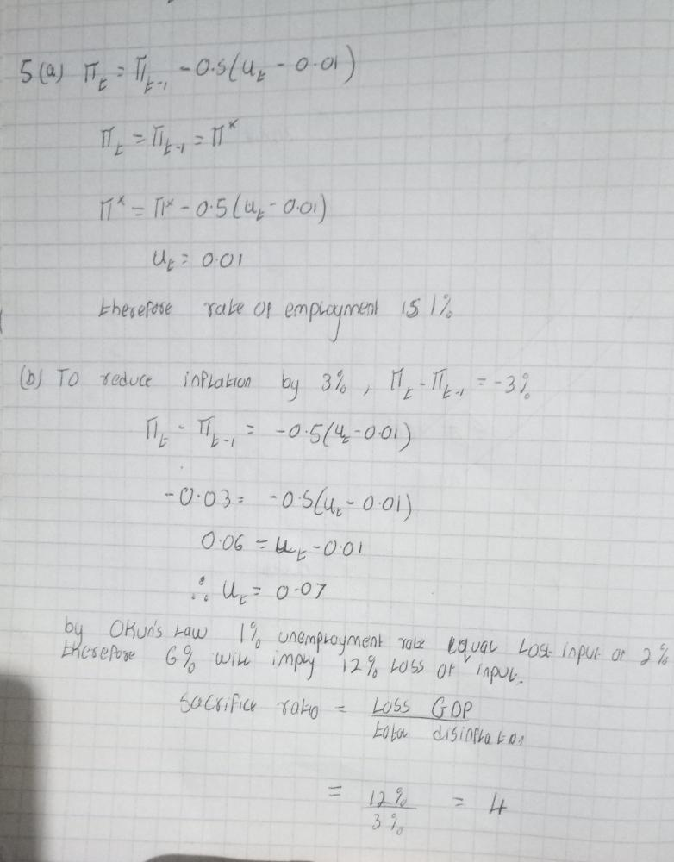
- Do flexible exchange rates permit a country to pick its own unemployment-inflation trade-off target? (10 marks)
The equilibrium price is determined by the demand and supply of the home currency in the exchange market. The point of equilibrium of the money is known as the Basic value of currency. The price of foreign money compared to
Home money is termed as the exchange rate. There are two categories of exchange rates based on how they are arrived at; fixed is the one determined by the government while the flexible is determined by the demand and supply in the
Foreign exchange market.in case of anything the government is responsible and can policies that can maintain the official exchange rate. The flexible exchange rate on the other hand gives the authority to the government to use stabilization policy.

